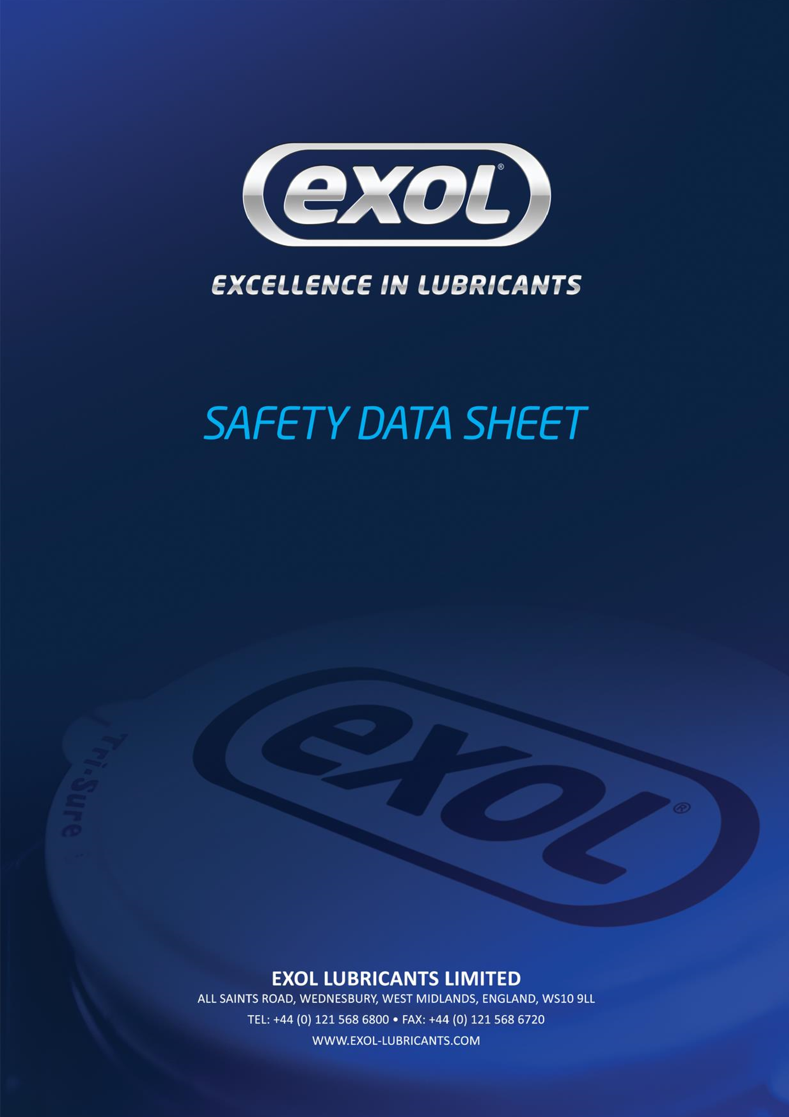

Libra EP 2

Libra EP 2
Product Code: Z005

SECTION 1 | IDENTIFICATION OF SUBSTANCE/MIXTURE AND OF COMPANY/UNDERTAKING
1.1 Product Identifier |  |  | Libra EP 2
Product Code |  |  | Z005
1.2 Relevant identified uses of the substance or mixture and uses advised against |  |  | Lubricating grease  Do not use in any other application.
1.3 Company |  |  | Exol Lubricants Limited  All Saints Road  Wednesbury,  West Midlands, WS10 9TS
1.4 Emergency Telephone Number |  |  | +44 (0) 121 568 6800 (Monday – Friday 08.30 – 17.00 hrs GMT)
1.5 Other Information |  |  | Preparation Date: 21/10/2015
SECTION 2 | HAZARD IDENTIFICATION
2.1 Classification of the substance or mixture  See section 16 for full text of H and R phrases |  |  |  | CLP Classification:  No classification required  Not classified as dangerous for the Environment  --------------------------------------------------------------------------------------------  Classification to DPD (1999/45/EC) and CHIP  No classification required
2.2 Label Elements |  |  |  | Labelling in accordance with CLP  None  Labelling in accordance with CHIP  None
2.3 Other Hazards |  |  |  | PBT: This substance is not identified as a PBT substance.
SECTION 3 | COMPOSITION/ INFORMATION ON INGREDIENTS
3.2 Mixtures  Hazardous Ingredients |  | CAS No. REACH Reg. No. |  |  | GHS Classification | Conc. %
Phosphorodithioic acid, mixed  O,O-bis(2-ethylhexyl and iso-Bu and iso-Pr) esters, zinc salts  The miner |  | 85940-28-9 01-211952121-61  al oil contains less than 3% DMSO extract as |  |  | Skin Irrit. 2; H315  Eye. Irrit. 2; H319  Aquatic Chronic 2; H411 measured by IP 346 | <1.5
SECTION 4 | FIRST AID MEASURES

4.1 Description of first aid measures
Eyes Wash out eye with plenty of water. Obtain medical assistance if soreness or redness persists.
Skin Wash skin with soap and water. If grease has been injected under the skin, seek medical advice immediately.
Ingestion Do not induce vomiting. Obtain medical attention. Inhalation No risk from inhalation.
4.2 Most important symptoms and effects, both No ill effects acute and delayed
4.3 Indication of immediate medical attention Eye Contact: immediately washout with plenty of water and special treatment needed, if necessary

SECTION 5 | FIRE-FIGHTING MEASURES

5.1 Extinguishing media Use water spray to cool containers. Use foam, dry chemical, carbon dioxide or suitable extinguishing media.
5.2 Specific hazards arising from the This product may give rise to hazardous fumes in a fire.
substance or mixture
5.3 Advice for fire-fighters Wear self-contained breathing apparatus.

SECTION 6 | ACCIDENTAL RELEASE MEASURES
6.1 Personal precautions, protective equipment and emergency procedures |  |  | See Section 8 for protective equipment.  Wash down floor area as spillage may be slippery. Larger spillage should be contained with sand or earth and collected in salvage container for disposal.
6.2 Environmental precautions |  |  | Protect drains from potential spills to minimise contamination. Do not wash product into drainage system.  In the case of large spills contact the appropriate authorities. In the case of spillage on water, prevent the spread of product by the use of suitable barrier equipment. Recover product from the surface. Protect environmentally sensitive areas and water supplies.
6.3 Methods and material for containment and cleaning up |  |  | Absorb into dry earth or sand. Protect drains using drain covers. Dispose of as hazardous waste.
6.4 Reference to other sections |  |  | Personal protective equipment: See section 8
SECTION 7 | HANDLING AND STORAGE
7.1 Precautions for safe handling |  |  |  | Avoid direct contact with the substance - Wear gloves. Care should be taken with dispensing equipment not to inject product under the skin.
7.2 Conditions for safe storage, including any incompatibilities |  |  |  | Store in a cool well-ventilated area.
7.3 Specific end use(s) |  |  |  | Intended for use as a high temperature lubricating grease.
SECTION 8 | EXPOSURE CONTROLS/PERSONAL PROTECTION
8.1 Control parameters Country |  | Substance Long Term (8 Hours TWA) Short Term (15 Mins)
None assigned  8.2 Exposure controls |  | Hand Protection: PVC gloves  Eye Protection: Wear approved safety goggles  Skin Protection: Normal work wear  Respiratory Protection: N/A
SECTION 9 | PHYSICAL AND CHEMICAL PROPERTIES

9.1 Information on basic physical and chemical Does not constitute a specification properties

Typical Values
Grades: |  | Libra EP 2
 | Units
Appearance |  | Brown smooth semi-fluid/stiff grease
Odour |  | Odourless
Odour Threshold |  | No data available
pH |  | Not applicable
Relative density | kg/l | 0.89-0.93
Solubility - water |  | Insoluble
Melting Point | °C | >185
Initial boiling point and range | °C | No data available
Flash point (PMCC) | °C | >200
Flammability |  | Auto-flammability > 200°C
Upper/lower flammability or explosive limits |  | No data available
Vapour pressure | kPa (0.1 mm Hg) | Not applicable
Partition coefficient n-octanol/water | Log Pow | Not applicable
Autoignition temperature | °C | >200
Decomposition temperature |  | No data available
Viscosity | mm²/s | No data available
Evaporation rate |  | Not applicable
Vapour density |  | Not applicable
Explosive properties |  | No data available
Oxidising properties |  | None

9.2 Other Information Not Applicable.

SECTION 10 | STABILITY AND REACTIVITY
10.1 Reactivity |  |  | Stable at ambient temperatures.
10.2 Chemical stability |  |  | Stable under normal conditions of use
10.3 Possibility of hazardous reactions |  |  | Hazardous reactions will not occur under normal transport or storage conditions. Decomposition may occur on exposure to conditions or materials listed below.
10.4 Conditions to avoid |  |  | Heat
10.5 Incompatible materials |  |  | Strong oxidising agents
10.6 Hazardous decomposition products |  |  | Combustion will generate: smoke, carbon dioxide and carbon monoxide.
SECTION 11 | TOXICOLOGICAL INFORMATION
11.1 Information on toxicologi  Acute Toxicity  - Oral  - Inhalation  - Dermal |  | cal effects  No toxic components present at levels to cause classification.  No toxic components present at levels to cause classification.  No toxic components present at levels to cause classification.
Corrosivity/Irritation  - Eye  - Skin  - Respiratory Tract |  | No components present that cause classification as an eye irritant.  No components present that cause classification as a skin irritant.  No components present that cause classification as a respiratory irritant.
Sensitisation  - Skin  - Respiratory |  | No evidence of sensitisation effects.  No evidence of sensitisation effects.
Repeated-dose Toxicity |  | No data available.
Mutagenicity |  | No evidence of mutagenicity.
Carcinogenicity |  | No evidence of carcinogenicity.
Reproductive Toxicty |  | No evidence of reproductive toxicity.
SECTION 12 | ECOLOGICAL INFORMATION
12.1 Toxicity |  |  |  | No information available.
12.2 Persistence and Degradability |  |  |  | Only slightly biodegradable.
12.3 Bioaccumulative Potential |  |  |  | This product, as supplied, is not expected to bio-accumulate.
12.4 Mobility in Soil |  |  |  | This product is poorly absorbed onto soils or sediments. Non-volatile.
12.5 Results of PBT and vPvB Assessment |  |  |  | This substance is not identified as a PBT or a vPvB substance.
12.6 Other Adverse Effects |  |  |  | None known.
SECTION 13 | DISPOSAL CONSIDERATIONS

13.1 Waste Treatment Methods
Send to registered waste disposal site using services of a registered waste disposal contractor. Disposal of packaging: Dispose of as normal industrial waste. NB: The user’s attention is drawn to the possible existence of regional or national regulations regarding disposal.

SECTION 14 | TRANSPORT INFORMATION
Not classified as dangerous goods for carriage under ADR/RID/AND/IMDG/ICAO/IATA regulations.
14.1 UN Number None
14.2 UN Proper Shipping Name |  | None
14.3 Transport Hazard Class |  | None
14.4 Packing Group |  | None
14.5 Environmental Hazards |  | Not classified as an Environmentally hazardous substance/Marine Pollutant
14.6 Special Precautions for User
14.7 Transport in bulk according to Annex II of Not applicable to packaged goods MARPOL 73/78 and the IBC Code

SECTION 15 | REGULATORY INFORMATION
15.1 Safety, health and environmental regulations/legislation specific for the substance or mixture |  |  | Supply regulations: DPD: Dangerous Preparations Directive; GHS: Globally Harmonised System of classification and labelling of chemicals; CLP: Classification, Labelling and Packaging regulations. Transport regulations: CDG: Carriage of Dangerous Goods regulations; ADR/RID/IMDG/ICAO/IATA regulations.
15.2 Chemical Safety Assessment |  |  | A chemical safety assessment has not been carried out for the substance or the mixture by the supplier.
SECTION 16 | OTHER INFORMATION

Third Issue
Second Issue March 2015: Changed composition
First Issue November 2013: Changed to new format.

Full text of classification data in sections 2 and 3
Skin Irrit. 2: H315 Causes skin irritation
Eye Irrit. 2; H319 Causes serious eye irritation
Aquatic Chronic 2; H411 Toxic to aquatic life with long lasting effects

